what is the need for power bi gateway

ChatGPT said:
The Power BI Gateway is needed to connect Power BI Service (cloud) to data sources that are located on your local computer, company server, or private network.
In simple terms, the gateway acts as a bridge between Power BI in the cloud and your data stored on-premises.
- Why do we need a Power BI Gateway?

Power BI Service (Cloud)
Online dashboards and reports
On-premises Data Gateway
Secure connection between cloud and local data
Local Data Sources
SQL Server · Excel files · Local databases
For example, suppose your company stores sales data in a SQL Server database inside its office network. You create a Power BI report and publish it to Power BI Service.
The report works in the cloud, but the database is inside the company's network. The gateway enables Power BI Service to communicate with that database.

2. Main uses of Power BI Gateway
  - Scheduled data refresh: Automatically refresh reports using the latest data from on-premises sources.
  - Live connection: Support live queries to certain data sources, such as SQL Server Analysis Services.
  - Secure connectivity: Connect cloud services to private data sources without directly exposing those sources to the internet.
  - Centralized management: Allow administrators to manage connections and credentials for multiple reports and users.
  - Data integration: Enable Power BI Service to use data stored across supported on-premises systems.

3. When do you need a gateway?
Data source or scenario | Gateway needed?
SQL Server inside your company network | Usually yes
Excel file stored on your local computer or a network drive | Usually yes
On-premises Oracle database | Usually yes
Data stored in a supported cloud database | Usually no
Excel file stored in OneDrive or SharePoint Online | Usually no
Importing data in Power BI Desktop only | No
The exact requirement depends on the connector, network configuration, and connection mode.

4. Types of Power BI Gateway
There are two main types:
  - On-premises data gateway (standard mode): Best for organizations. It can be shared by multiple users and supports multiple data sources and services.
  - On-premises data gateway (personal mode): Designed primarily for an individual Power BI user and personal scheduled refresh scenarios. It has more limited functionality.

5. How does the gateway work in a real project?
Consider a daily sales report:
  - Your sales data is stored in SQL Server on a company server.
  - You create a report in Power BI Desktop.
  - You publish the report to Power BI Service.
  - You configure the gateway and connect it to the SQL Server data source.
  - You configure scheduled refresh in Power BI Service.
  - The gateway connects to SQL Server and retrieves updated data when a refresh runs.
  - Users see the updated report in the Power BI Service.
Important: The gateway computer must be running and connected to the network for refreshes or queries that depend on it.

6. Interview answer
If an interviewer asks, "Why do we need a Power BI Gateway?", you can say:
"A Power BI Gateway acts as a secure bridge between Power BI Service and on-premises data sources. It enables scheduled data refresh and, for supported sources and connection modes, live queries. For example, if our SQL Server database is hosted inside the company's network, we use a gateway so Power BI Service can access the data without directly exposing the database to the internet."
- You said:
i have a microsoft sql server installed in Azure VM. do i need power bi gateway t connect to the data tables in sql server databases lying in Azure VM
- ChatGPT said:
Yes, you may need a Power BI Gateway to connect to SQL Server installed on an Azure VM — but it depends on how Power BI connects to the VM.
Even though your SQL Server is hosted in Microsoft Azure, it is still a SQL Server instance running on a virtual machine. The key question is whether Power BI Service can reach it directly over the network.

When do you need a gateway?
Your scenario | Gateway needed?
Power BI Desktop connects to SQL Server on the Azure VM | Usually no
You publish the report and want scheduled refresh in Power BI Service | Depends on network access and connection configuration
SQL Server is accessible only through a private IP or private network | Usually yes
SQL Server has a publicly reachable endpoint and allows secure connections from Power BI Service | Potentially no
Microsoft specifically treats SQL Server running on an Azure VM as an infrastructure-as-a-service (IaaS) data source that generally requires a gateway when the VM is inside a private network.

Microsoft Learn
+1

My recommendation for your setup
If your SQL Server is installed on an Azure VM and you want to publish Power BI reports to the Power BI Service, the simplest approach is usually:
  - Install the On-premises data gateway (Standard mode) on the Azure VM running SQL Server, or on a separate Windows VM that can access SQL Server.
  - Configure a SQL Server connection in the Power BI Service.
  - Configure the required credentials and scheduled refresh.
You generally don't need to open SQL Server directly to the public internet for this setup.
Microsoft Learn
+1

One question to confirm your exact setup
How is your SQL Server on the Azure VM accessed?
1. Network access to SQL Server
Private IP only (Azure VNet)
Public IP with SQL Server port 1433 accessible
I'm not sure
2. What do you want to do?
Connect from Power BI Desktop only
Publish reports and schedule data refresh
Publish reports using DirectQuery for near-real-time data
Log in for personalized, step-by-step guidance.
Log inSign up for free
- You said:
My SQL Server is installed on an Azure VM. Network access: Private IP only (Azure VNet). Power BI goal: Publish reports and schedule data refresh. Please advise whether I need a gateway and how to configure it.
- ChatGPT said:

Step-by-step configuration
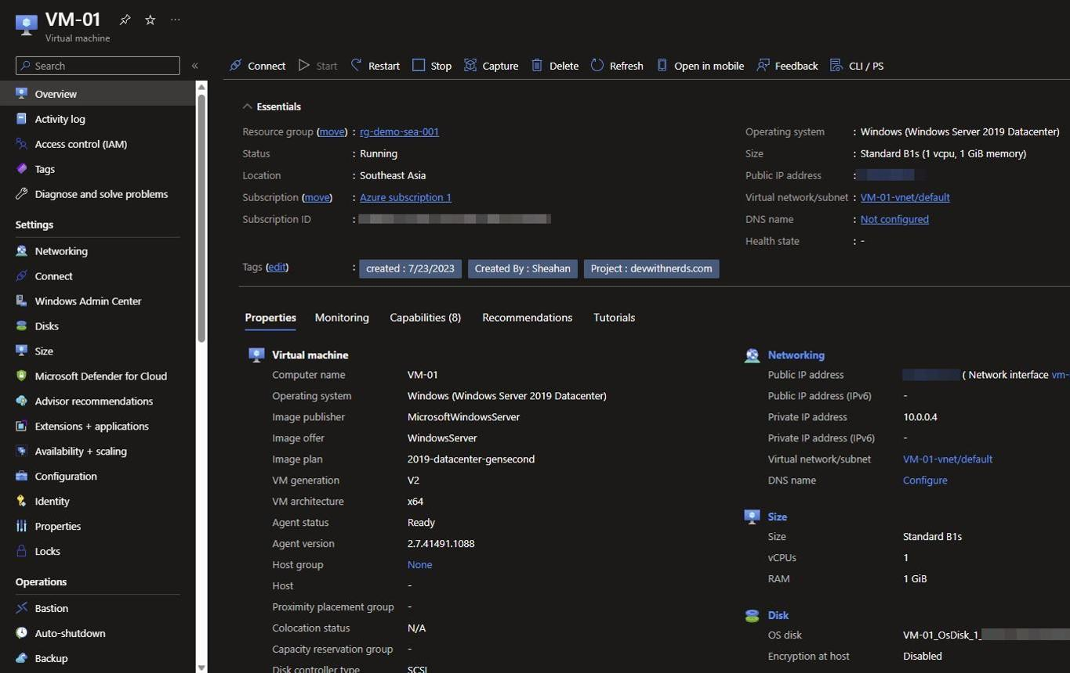
Step 1 — Choose where to install the gateway
Install the gateway on either:
  - The same Azure VM as SQL Server, if it has sufficient resources.
  - A separate Windows VM in the same VNet, or a peered VNet with network access to SQL Server.
For a production environment, a separate VM can help isolate gateway workloads from SQL Server.
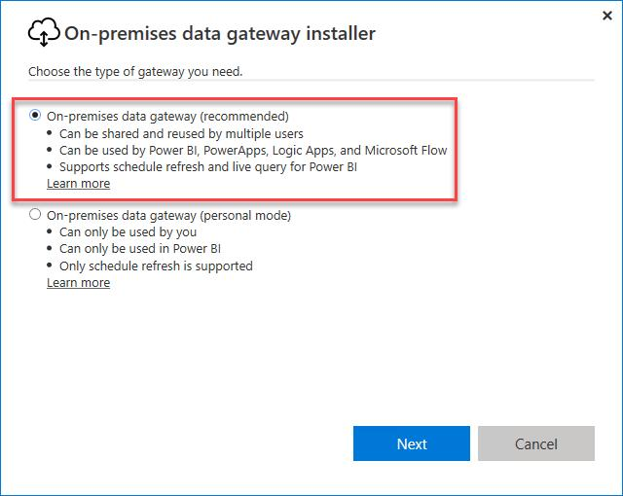
Step 2 — Install the standard gateway
Download it from Microsoft's official Power BI Gateway page .
  - Run the installer on the selected Windows VM.
  - Choose On-premises data gateway (recommended), also called Standard mode.
  - Sign in with your organizational Microsoft account.
  - Register the gateway with a recognizable name and recovery key.
Keep the VM running and ensure it can make the gateway's required outbound connections. You normally don't need inbound internet access to the gateway.
Microsoft Learn
+1
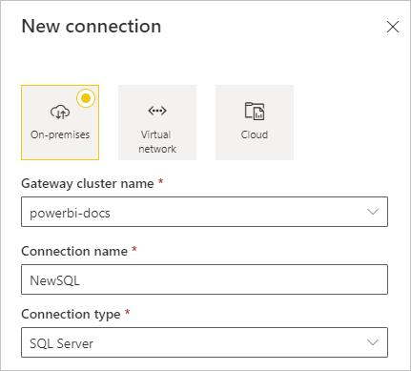
Step 3 — Add SQL Server as a gateway connection
In Power BI Service :
  - Open Settings → Manage connections and gateways.
  - Select New and choose an on-premises connection.
  - Select SQL Server as the connection type.
  - Enter the SQL Server's private IP address or DNS name and the database name.
  - Select the authentication method and enter credentials with permission to read the required tables.
  - Save the connection.
The server and database names must match those used in Power BI Desktop.
Microsoft Learn
+1
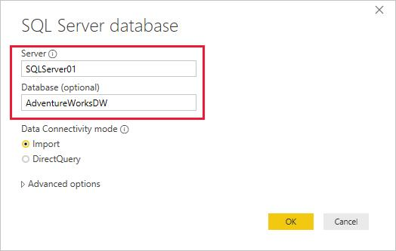
Step 4 — Connect and publish your report
  - In Power BI Desktop, choose Get data → SQL Server.
  - Enter the same private IP/DNS name and database name.
  - Choose Import if you want to use scheduled data refresh.
  - Build the report and select Publish to send it to your Power BI workspace.
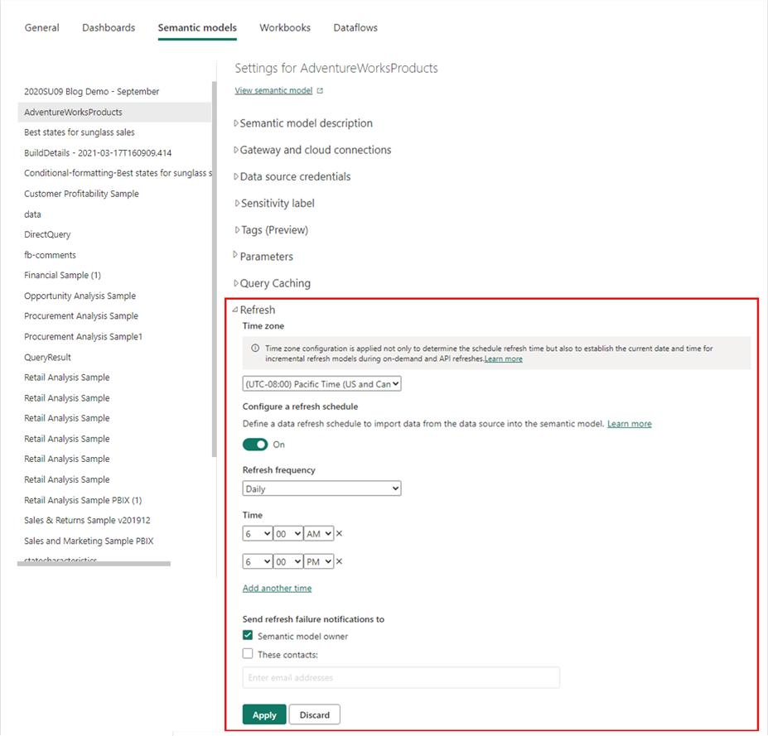
Step 5 — Enable scheduled refresh
In Power BI Service:
  - Open your workspace and find the published semantic model (formerly called a dataset).
  - Open its Settings.
  - Under Gateway and cloud connections, map it to your gateway connection.
  - Verify the connection status and credentials.
  - Under Refresh, enable Schedule refresh and select the desired frequency and time.
  - Run a test refresh and check the refresh history.
Microsoft Learn
+1

Important Azure networking checks
Before testing refresh, verify these settings:
  - SQL Server connectivity: The gateway VM must be able to reach the SQL Server private IP on the configured SQL port, commonly TCP 1433.
  - Azure NSG and Windows Firewall: Allow SQL traffic from the gateway VM to the SQL Server VM. Don't expose port 1433 publicly just for Power BI.
  - Outbound connectivity: Allow the gateway VM to reach the required Microsoft endpoints. The standard gateway initiates outbound connections to the Power BI service.
Microsoft Learn
+1
  - SQL authentication: Ensure the credentials configured in Power BI Service have the necessary database permissions.
  - Matching connection details: Use the same server and database names in Power BI Desktop and the gateway connection.
Microsoft Learn

An alternative: Microsoft-managed VNet data gateway
You could also consider a VNet data gateway, which doesn't require installing gateway software on a VM. It is designed for connecting Power BI to supported data sources within an Azure VNet. However, it requires an eligible Fabric or Power BI Premium capacity and has specific regional and data-source support requirements. Confirm that your SQL Server on an Azure VM is supported for your configuration before choosing this route.
Microsoft Learn
+2
For your setup, I would start with the standard gateway installed on a Windows VM that can reach SQL Server privately. It's a straightforward approach and doesn't require making your database publicly accessible.
Official guides:
  - Install the standard gateway
  - Configure SQL Server as a gateway data source
  - Configure scheduled refresh

